Brief Promo for FRAZZ Album

“Early Tom Waits meets late Joe Henry while
waiting for Leonard Cohen to show”
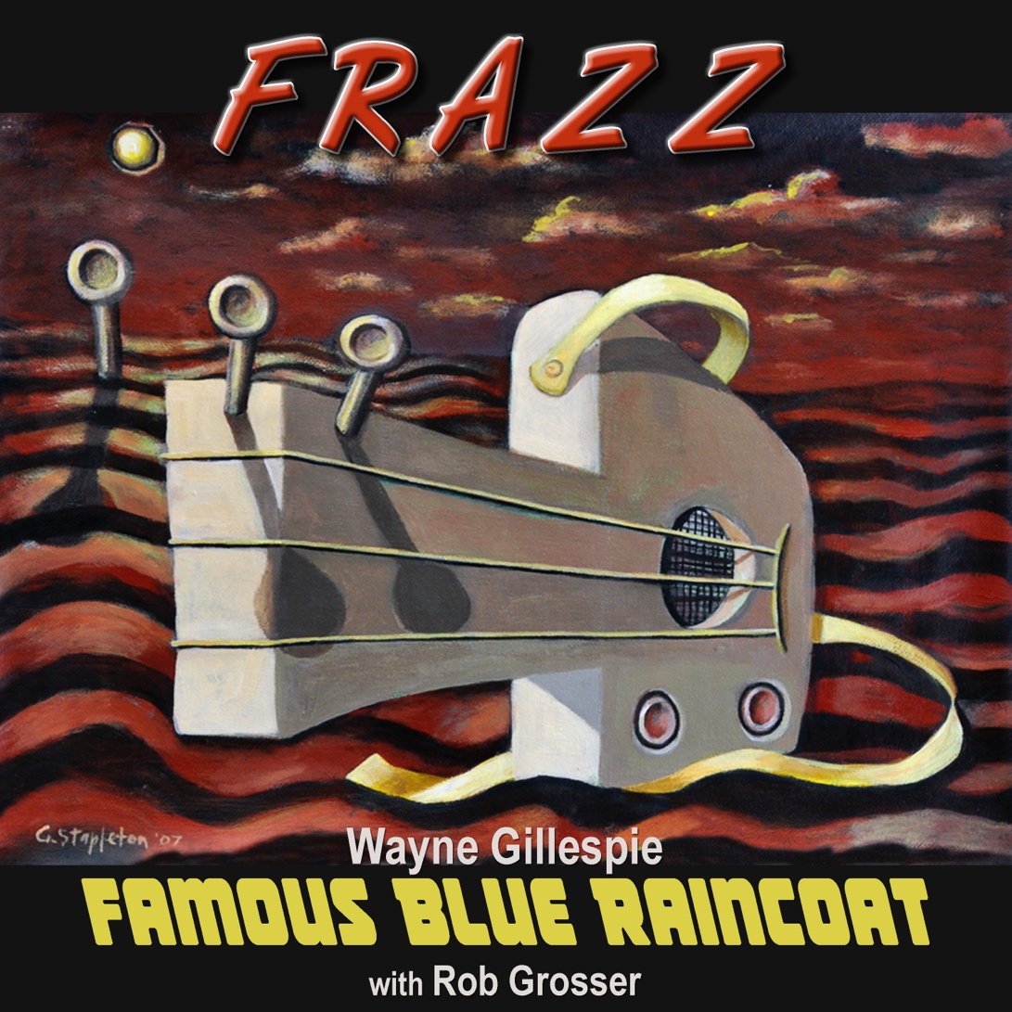

“When I say this new album is all over the place I mean it as a total compliment, such is the diversity of songs, styles, and sounds on it....Folk, Rock, and Jazz. . . it’s FRAZZ!" Stuart Coupe 24/6/2022

“A jazzy Lou Reed, film noir, Miles Davis kind of vibe (Bananas#2)” UK podcasters @yhhtmpc. August 2022

“I f… love this” @yhhtmpc November 2022

“Like Leonard Cohen in a cosmic country folk dream (Delusions)-Post to the Wire- Sep 2022

“The hubris of calling themselves Famous Blue Raincoat is definitely justified ..I don’t know about Cohen for me there is an essence of Lou Reed in that track (Chapel Street)..” John Lampe Tempo The Pulse (94.7FM The Pulse) Oct 2022

“Gillespie has stretched himself and pushed the boundaries here with the colour from his chiming guitar, the saxophone of Robertson on the almost eight minute, increasingly menacing Jealous Man (bleakly funny if your humour runs cold and black) and the popping Afro-sound of Papa Wemba (She Dances). Lyrically these songs are also multi-layered and repay careful attention to their detail.” Graham Reid, 6/3/2023. FRAZZ_Elsewhere.com.nz

"I’m loving this set of songs…love the banjo on Bananas plus the horn stuff … such cool playing and Wayne’s voice is perfectly tuned to the lyrics ..he is such a unique artist and I’ve always thought his music was like a collection of gems … like threading a string of pearls that trace your life one song after another . Rose Bygrave (Goanna)

“Wayne Gillespie well done! Love the sound of this” Marcia Howard (Goanna)

“(Brick By Brick) -That's good! Saxophones sound like Bowie 'plastic soul' era" Martin Phillips (The Chills)

"Papa Wemba (She Dances), what a wonderful song! " Geoffrey Stapleton (Gangajang)

"I love this song Brick By Brick Wayne.. the fucked-up sax and the Wah Wah and the brilliant lyrics that paint the picture so fluidly.. it’s going straight to a playlist!" Mel Forbes ( Swamp Daisies)

NZ born Sydney resident Wayne Gillespie releases his 6th album with band Famous Blue Raincoat & Rob Grosser.

Gillespie who cut his teeth playing London Folk Clubs and Busking in Paris Metros in the 80's returned to NZ, releasing 3 albums and making the finals of the NZ Music awards in 1984 & 1988.

Gillespie has shared the stage with the likes of Suzanne Vega, Neil Finn, the late Chris Whitley, Stan Ridgeway, Ed Keupper, (The Saints) , Colin Hay, Margaret Urlich, Dave Dobbyn, Amanda Brown (Go-Betweens) to name a few.

These songs are a collaboration with drummer/percussionist/Producer/Engineer Rob Grosser who has worked with some of Australia’s best musicians including the late Pete Wells of Rose Tattoo, Jimmy Barnes, Tim Gaze , Bob Daisley (Ozzy Osbourne/Gary Moore) as well as overseas artists such as Bob Margolin (ex- Muddy Waters), Jon Lord, Ian Gillian (Deep Purple) as well as Steve Morse.

So the album FRAZZ concoction of Alt/Folk/Rock/Jazz - Tracks with traces of Rock-edge, spiced with cheeky surrealism, Jazz juices, Folk reverence, African flavours, Hypnotic Grooves and Dark Tales. Released 24 June 2022.

FRAZZ Album -Soundcloud Link Private

FRAZZ Album Info -Wayne Gillespie & FBR

FRAZZ Album Pre-Save/Streaming Links

